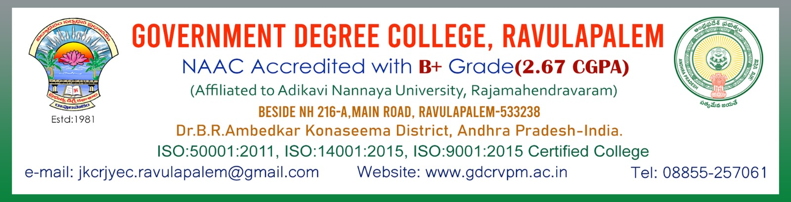

**DAPERTMENT OF POLITICAL SCIENCE**

**ANDRA PRADESH FORMATTION DAY 01-11-2023**

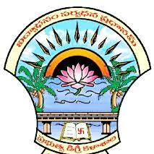

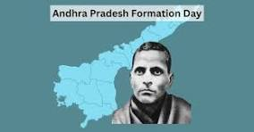

**MINUTES OF THE MEETING(30-10-2023)**

The Department of Political Science, Govt Degree College, Ravulapalem met with The Department of Political Science Sri.S.Rajendra Prasad to conduct Andhra Pradesh Formation Day for inculcate the students among the Andhra Pradesh Formation Day 1st November .2023.

**Members Attended:**

1.Sri.S.Chinababu (Lecturer in Economics)

2.Dr.B. Haribabu I/C of the Department

3. Sri.V.Siddhardha Kumar (Lect in History)

4. Sri.S Rajendra prasad lec in Pol. Science

**MINUTES OF THE MEETING**

Keeping in view the significance of Andhra Pradesh Formation Day Department of Political science proposed to celebrate and inculcate and inspiring the citizens towards Good governance.

.

**RESOLUTION**

It is unanimously resolved to request the principal to accord permission to conduct the Andhra Pradesh Formation Day1st November 2023 in offline mode.

Signatures:

1. Sri.S.Chinababu (Lecturer in Economics)
2. Dr.B. Haribabu I/C of the Department
3. Sri.V.Siddhardha Kumar (Lect in History)

4. Sri.S Rajendra prasad lec in Pol. Science

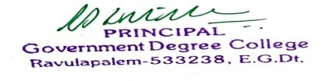

Principal

Letter to the Principal

The Principal, Dept of Pol.Science& History,

Government Degree College, Government Degree College

Ravulapalem.

The Department of Political Science, Govt Degree College, Ravulapalem met with The Department of Political Science Conducted the Andhra Pradesh Formation Day 1st November .2023.

Respected principal,

The Department of Political Science, Govt Degree College, Ravulapalem met with The Department of Political Science Conducted the Andhra Pradesh Formation Day 1st November .2023. Every year Andhra Pradesh Formation, Day for inculcate and inspiring the citizens. So, we the lecturer in Political Science are going to conduct National Constitution Day for inculcate and inspiring the citizens towards good governance. So, we the lecturers in Political Science and history are going to conduct the Andhra Pradesh Formation Day 1st November .2023.

Thanking you sir,

Your’s faithfully,

Sri S. Rajendra Prasad,

Lecturer in Political Science

**Government Degree College Ravulapalem**

**Department of Political Science &History**

**Dt 30.10.2023**

**CIRCULAR**

All the staffand students are here by informed that on the occasion of Andhra Pradesh Formation Day for inculcate and inspiring the Students towards Formation of Andhra pradesh going to conduct this programme on 01 November 2023. So, all are requested to attend this programme at Mana TV Room on 01 November 2023. at 11.00 am make it success

**Signatures:**

I BA

II BA

III BA

I B.COM (GENRAL & CA)

II, B.COM (GENRAL & CA)

III BCOM (GENRAL & CA)

I BSC (MPC ,MPCS & IOT )

II BSC (MPC ,MPCS & IOT )

III BSC (MPC ,MPCS & IOT )

I BSC (CBZ & HBC)

II BSC (CBZ & HBC)

III BSC (CBZ & HBC)



PRINCIPAL

**GOVERNMENT DEGREE COLLEGE, RAVULAPALEM**

**ANDHRA PRADESH FORMATION DAY**

**01.11.2022**

**REPORT**

**Objective**

To make a student aware of involvement and inculcate increase the feeling of Freedom fighter Potti Sriramulu had laid down his life after undertaking fast-unto-death for over 56 days for the formation of Andhra state.

Andhra Pradesh Formation Day conducted by Department of Political science and History on 01st November 2023.In Government Degree College, Ravulapalem. The program was started at 02.00pm in ManaTv Room Chief Guest of the program was Vice–Principal BH.SVVNS Murthy sir, and IQAC Coordinator Smt.V.Sailaja , Head of the department of Political science Dr.G.Haribabu , Head of the department of History Kum.G. Soni, S.Chinabau Lecturer in Economics, V.Siddhardha Kumar Lecturer in History, S.Rajendra Prasad Lecturer in Political Science and etc. participated in this program. Dr.G.Haribabu gave a message to Formation of Andhra Pradesh is the awareness of a In an effort to protect the interests of the Telugu people of Madras State, PottiSreeramulu attempted to force the Madras State government to listen to public demands for the separation of Telugu-speaking districts from Madras State to form Andhra State. Finally vote of thanks was given by Sri.V.Siddhardha Kumar Lecturer in History to all the faculty members are participated in this program. The whole College students are participated in this program.

**PHOTOS OF THE EVENT**

